|  |
| --- |
|  |
| ‘killcraft’ user manual |
|  |

|  |
| --- |
| Robert  10/28/2011 |

**F:\Havant 2010 - 2012\Year 2\Unit 22 - Computer Games Development\Assingment 2 - Implementation\vbGame\vbGame\Resources\Images\Sprite\AI\Enemy_Left.gifF:\Havant 2010 - 2012\Year 2\Unit 22 - Computer Games Development\Assingment 2 - Implementation\vbGame\vbGame\Resources\Images\Sprite\Sprite_right.gif**

I shall kill you!

Contents

[PURPOSE 3](#_Toc309204465)

[INSTALLING THE GAME 3](#_Toc309204466)

[UNISTALLING THE GAME 3](#_Toc309204467)

[NAVIGATING GAME MENUS 4](#_Toc309204468)

[CREATIVE MODE 5](#_Toc309204469)

[SURVIVAL MODE 6](#_Toc309204470)

[GAME CONTROLS 7](#_Toc309204471)

[FAQ 8](#_Toc309204472)

# PURPOSE

‘Killcraft’ is a single-player 2-Dimensional tile-based engine. The player controls a sprite, in a non-persistently timed single-player world. The game houses two game modes, creative and survival.

Creative mode allows the player to place blocks, known as tiles in any permutation possible. The games objectives have similarities with that of ‘Minecraft’ and ‘Terraria’. Likewise ‘killcraft’ focuses on creativity; by placing various tiles the player can build a world to their taste.

Shooting fireballs at enemies is the game’s survival mode primary objective. For each enemy destroyed a new one spawns with an increased field-of-view and health. The player has thirty-seconds to obliterate as many enemies possible. If the player collides with an enemy the player’s health is reduced, once hit zero, game over! The player’s score is then saved onto a high-score board.

# INSTALLING THE GAME

To install you first need to check that you have administrator privileges.

1. Run the executable downloaded, named “killcraft.exe”.
2. Follow the installation instructions.
3. The game is now installed, to execute navigate to your start menu on your Windows based PC. The executable application is found under the directory named ‘killcraft’.

# UNISTALLING THE GAME

To uninstall ‘killcraft’ on your Windows based PC you need to follow the following instructions.

Assumed you’re on a Windows 7 based PC

1. Navigate to Start 🡪 Control Panel 🡪 Programs 🡪 Uninstall a program.
2. Select ‘killcraft’ from the installed programs list, right click and select uninstall.

# 

# NAVIGATING GAME MENUS

Once the killcraft.exe has been executed and the game loads you’ll be greeted with the following flash screen. The splash screen acts as the game’s main menu.

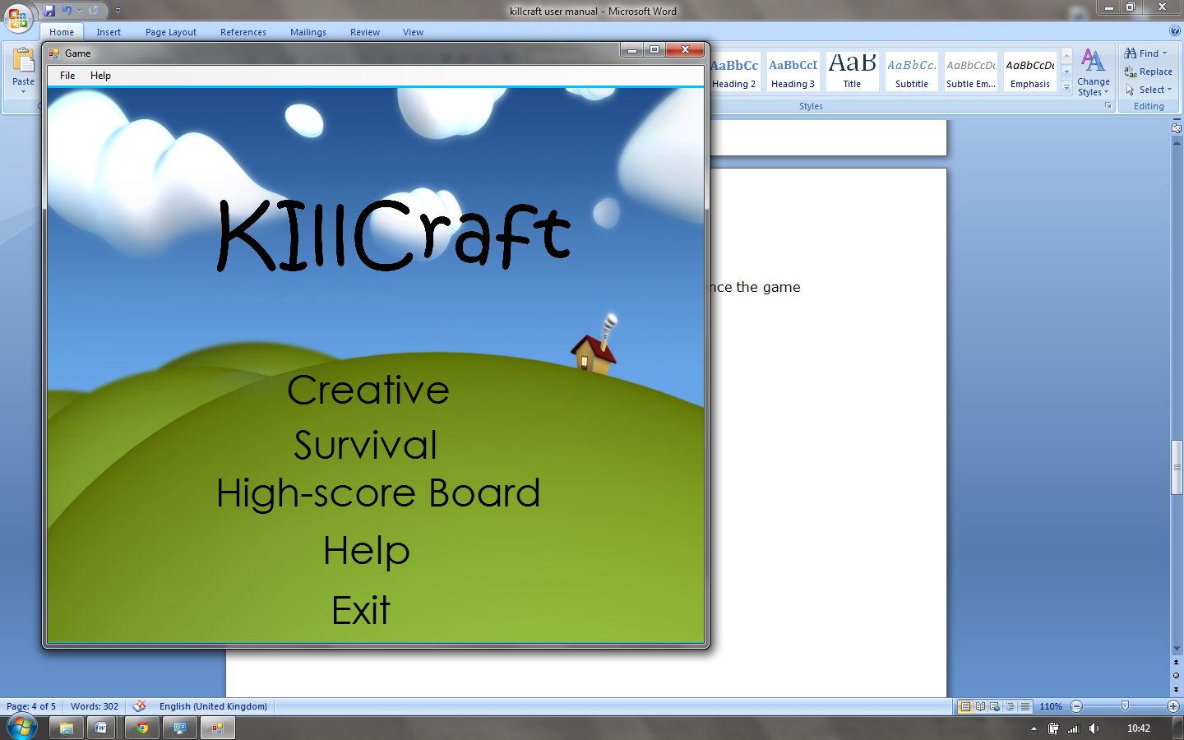

1. Click to start the game’s creative mode
2. Click to start the game’s survival mode
3. Click to view high-score board
4. Click to view help menu
5. Click to exit the game
   1. When in-game to bring up menu go to File 🡪 Stop
   2. Or File 🡪 Exit to exit

Game Modes

# CREATIVE MODE

The primary objectives of ‘killcraft’ creative mode are to place tiles to create things. But before you can do any of this you need to know how to select tiles to place.

**Starting creative mode**

First start ‘killcraft’ in creative mode; you’ll be greeted with the following screen.

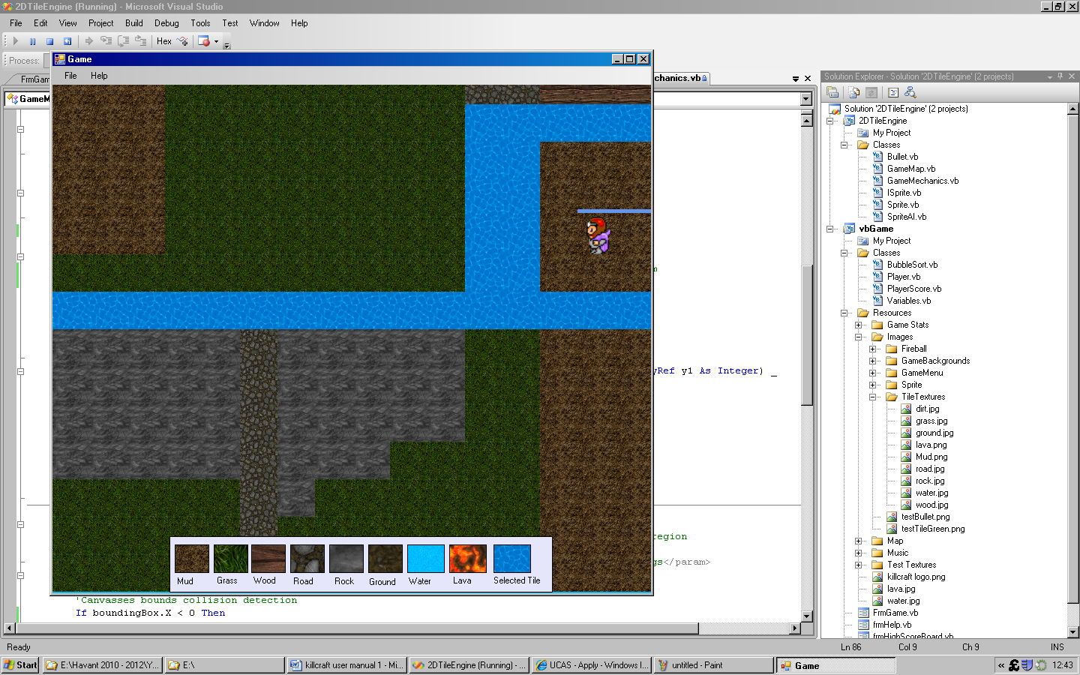

1. Press the ‘y’ key to bring up the tile selection pane.
2. Click a tile on the tile selection pane you wish to place.
3. Press ‘t’ to place the tile a tile in front of your sprite’s current direction and position.

|  |  |  |  |  |  |
| --- | --- | --- | --- | --- | --- |
| Tile Types | |  |  |  |  |
| Tile Number | **Tile** | **Image** | **Tile Number** | **Tile** | **Image** |
| 0 | mud | E:\vbGame\TileTextures\ground.jpg | **4** | road | E:\vbGame\TileTextures\road.jpg |
| 1 | grass | E:\vbGame\TileTextures\grass.jpg | **5** | Rock | E:\vbGame\TileTextures\rock.jpg |
| 2 | Wood | E:\vbGame\TileTextures\wood.jpg | **6** | ground | E:\vbGame\TileTextures\mud.jpg |
| 3 | water | E:\water.jpg | **7** | lava | E:\lava.jpg |

There are many different type of tiles, with different designs. This table represents the selectable tiles.

Water, lava, rock and wood cannot be passed over by the player or the AIs sprite. You can use this knowledge to devise tactics to outflank the opposing enemies.

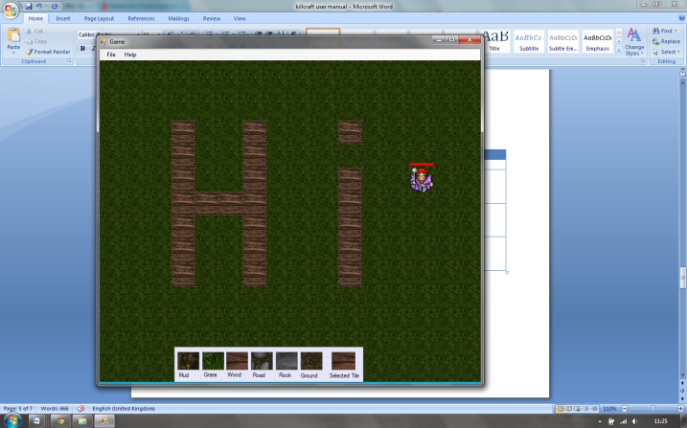Example creation:

# SURVIVAL MODE

Survival mode primary objectives are to destroy as many enemies in 30 seconds. For each enemy killed you get 100 points (25 points each hit). Each time an enemy is disposed off, it spawn’s in a new pseudorandom location.

**Starting survival mode**

First start ‘killcraft’ in creative mode.

The ‘space bar’ is used to shoot fireballs. Once the game time has run out, assuming you have not be killed, you’re required to enter your name in order to be added to the game’s high-score board; this can be accessed from the game’s main menu. If your health reaches 0 you’re dead and game over!

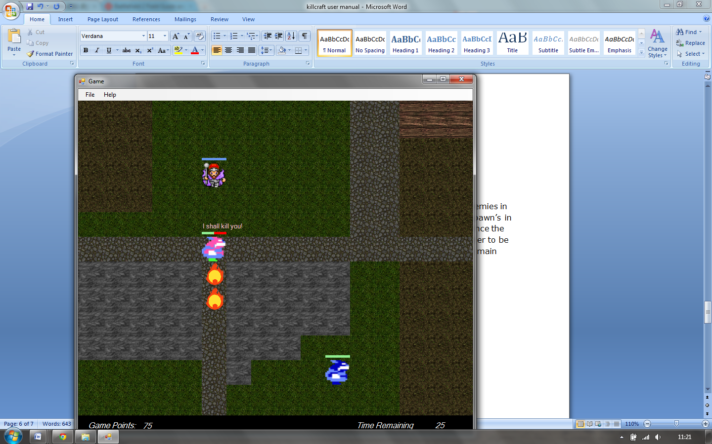

Figure : Example Game-play

Navigating your Sprite

# GAME CONTROLS

|  |  |
| --- | --- |
| General Sprite Controls | |
| Action | **Control** |
| Move Left | left Arrow Key 🡨 |
| Move Right | Right arrow key 🡪 |
| Move Down | Down Arrow Key |
| Move Up | Up arrow key |

|  |  |  |
| --- | --- | --- |
| Creative Mode Extra Sprite Controls | | |
| Action | **Control** | |
| Place tile | | ‘t’ key |
| Tile Selection Menu | | ‘y’ key |

|  |  |  |
| --- | --- | --- |
| Survival Mode Extra Sprite Controls | | |
| Action | **Control** | |
| Fire Fireball | | Space Bar |

# F:\Havant 2010 - 2012\Year 2\Unit 22 - Computer Games Development\Assingment 2 - Implementation\vbGame\vbGame\Resources\Images\Sprite\Sprite_right.gif

# 

# FAQ

***Will the game run on Mac OS X or Linux?***

No, ‘killcraft’ is only playable on Windows based PC. Windows XP, Vista and 7.

***Error when Installing?***

Refer to the section on installing ‘killcraft’.

***Uninstalling ‘killcraft’?***

Refer to the section on uninstalling.

***How many fireballs can you fire at any one time?***

As many as your PC can handle, no finite amount explicitly programmatically specified.

***What game genre does ‘killcraft’ falls under?***

‘killcraft’ is a 2D role-playing sandbox style game.

***How can I reset the high-score board?***

Navigate to your ‘killcraft’ installation directory and delete PlayerScores.txt. This will reset the games high-score board.

